No Code – The Next Seismic Shift the Industry Needs

The industry has drastically shifted over the years in the past decade alone! Software development has come a long way since the early 2000’s The past decade has seen so many seismic shifts that have changed software development.

**Seismic shifts**

Virtualization began reducing wait times for server deployment and application creation by 10 fold. The introduction of containers further isolated applications from their hosted environments making it possible to easily migrate them. Enterprises began to shift from traditional programming practices to more modern ones like “Cloud First” strategy and the availability of cloud services then paved the way for developers to provision, build, and deploy applications and to provide SaaS, PaaS on private, public or hybrid cloud environments. Rapid consumerisation of IT through browser based and mobile apps with cloud as an enabler required greater innovation and shifts in software development to keep up with the pace.

Agile methodology thus enabled releasing software quicker in smaller increments and then adjusting and iterating from there. IT Operations needed to embrace DevOps to enable continuous integration and continuous deployment to keep up with the high growth business environment. Thanks to Agile and DevOps practices, greater collaboration is also now enabled between development and business teams, and development and IT Operations teams respectively.

**Current challenges**

There are still a plethora of challenges still prevalent in the IT industry. The big question is whether enterprises will be able to keep pace with digital transformation and deliver business outcomes as innovation and emerging IT technologies continue to change and disrupt the market at an even accelerated pace. Enterprises need to reinvent their business by leveraging the power of digital, build new revenue models by bringing innovating new products and services all while retaining the customer.

Current challenges that enterprises face include having legacy systems and highly customised solutions, complex business processes, multiple and disparate technology stacks, lack of end-to-end business knowledge, lack of systems and processes to manage the data explosion, huge shadow IT that is ungoverned and massive skill gaps and shortage of resources. Digital transformation will only be successful when driven by people who understand both business strategy and technology to address these issues. According to Erik Dörnenburg of ThoughtWorks, currently where consultation and

collaboration exists between IT and business and IT seen as an enabler, will instead need to be replaced by technology becoming the heart of business.¹

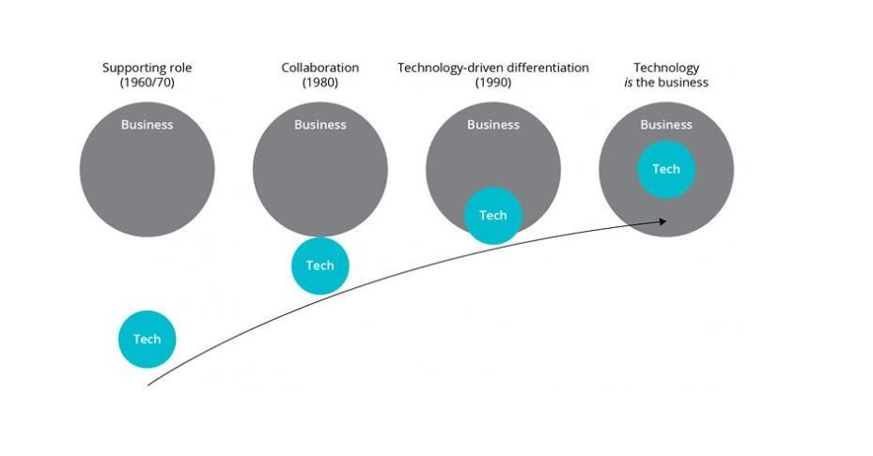

**No Code Application Development – the Next Seismic Shift**

1. **Being the heart of the business**

The question is how to make technology the heart of the business enterprise? This is where No Code Application Development can bring in the next seismic shift in bringing about further acceleration in development and innovation. The gear shift that No Code provides is enabling business and IT embedded together as one unified team enabling business decisions and strategy driven by the power of technology to accelerate innovation and meet customer needs in a rapidly changing market. Business and IT as one embedded team can now share the same visual representation of data models, business process and customer centric view while ensuring all enterprise standards of quality, security are fully adhered to.

Forrester indicates that low code can accelerate software development by 10 times.² I can attest to this having seen Leading No Code Application Development platform WEM in action compared to traditional development. Having pre-built drag and drop modelers, unified data models, DevOps support, easy support for integration using industry standard protocols, built in enterprise grade security features, single click cloud deployments, development almost feels real time!

1. **Legacy modernisation**

A big challenge in digital transformation involves legacy systems. Patches or workarounds are temporary solutions, and these remedies create incompatibilities and discrete technology stacks resulting in increased operating costs in the long run. Legacy technology also means a higher exposure to operational and security risk, especially due

to extensive and unique levels of customisation and the declining lack of knowledge within the business as to how such complex systems work.

No Code Application development can help with modernisation irrespective of whether a choice is made to leverage or extend an application’s features and value by making them available through services via APIs or refactor or rebuild. This will ensure ease of real time deployment without downtimes, increased configurability to market needs, and aptitude to integrate with residing business applications while delivering massive increases in productivity and business growth.

1. **Skills Gap**

The digital skills gap is widening rapidly. There is a huge demand for creating software applications and there are not enough skilled people to do this. Microsoft predicts that over 500 million new apps will be built in the next five years, more than all apps in the last 40 years.³ A McKinsey global survey showed that 90% of executives were already experiencing skills gaps in their workforce and expecting this to increase in the next few years.⁴ A traditional development model requires a Business Analyst, Designers, Developers, Database experts, Data Modelers, Integration experts, specialist mobile application developers, front end experts, security experts, testers, cloud provisioning experts and so on.

In No Code application development even while developing complex applications, the number of specialist resources required is at least three times less. Platforms like WEM enable developers to intuitively design full-stack applications and visualize each step in real-time during the application development process. Both the front-end and back-end of your application is built using the same interface. Developers can build applications once and publish these to different portals to easily service multiple groups of users or customers. Mobile application development is built using the same interface. Built in full application lifecycle management offers a continuous process of development, testing, deployment and maintenance.

Developers can easily build enterprise grade secure applications as security is built into the architecture with multiple layers of protection. With support for microservices architecture and flexible DevOps topologies, no code developers on platforms like WEM can increase their productivity and focus their time on what is really required. All this really helps in addressing the skills gap and be able to deliver more and increase productivity.

1. **Elimination of Shadow IT and Governance**

Shadow IT is a huge problem and Gartner predicted way back in 2016 that that one-third of all successful attacks experienced by enterprises will be through their shadow IT resources.⁵ It introduces serious security risks to enterprises through data leaks and potential compliance violations as IT cannot ensure it meets security standards. Shadow IT has grown exponentially through the years through use of widely available cloud-based services, systems, devices, applications without explicit IT department approval, ownership and governance. Beyond security risks, shadow IT can also waste money if different business units are unknowingly purchasing duplicate solutions.

No Code Applications help eliminate use of shadow IT and gives business the agility they need while ensuring all enterprise standards for security and compliance are adhered to while championing innovation. IT departments can automate governance on these platforms and eliminate potential points of risk and failure for the enterprise.

**Conclusion**

Enterprises have no choice but to keep pace with the speed of innovation and emerging IT technologies if they want to compete and succeed. No Code application development enables a connected strategy that builds on the seismic shifts that the industry has already embraced like Agile, DevOps, Cloud Strategy and will be the enabler to embrace newer emerging technologies like AI, IoT, ML and further automation. Gartner predicts that 50% of medium to large enterprises will adopt low-code/no-code (LCNC) as one of their strategic platforms by 2023.⁶ It is time to embrace No Code as the next seismic shift.